Cumulative – 03

1. An API which updates a Teacher

1. A web page that allows a user to enter updated Teacher information

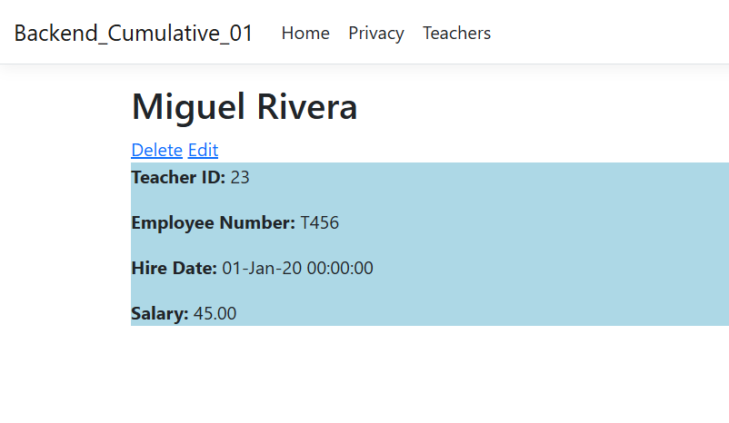

Adding string to salary, which holds decimal value

